2012.06 ADSP

**Saliency Map Tutorial**

**b97901095@ntu.edu.tw**

Content

[1 Motivation 1](#_Toc328681639)

[2 Introduction to Visual Saliency 2](#_Toc328681640)

[2.1 Definition 3](#_Toc328681641)

[2.2 Saliency in Psychology 4](#_Toc328681642)

[2.3 Saliency in Neuroanatomy 5](#_Toc328681643)

[3 Introduction to Saliency Map 5](#_Toc328681644)

[3.1 Definition 6](#_Toc328681645)

[3.2 Buttom-Up Approach 7](#_Toc328681647)

[3.3 Top-Down Approach 7](#_Toc328681648)

[4 General Computational Framework 8](#_Toc328681649)

[5 Proposed Computational Mechanisms 9](#_Toc328681650)

[5.1 A Model of Saliency-based Visual Attention for Rapid Scene Analysis--L. Itti, C. Koch and Ernst Niebur(1998) 9](#_Toc328681651)

[5.1.1 Architecture of Model 9](#_Toc328681652)

[5.1.2 Visual Preprocessing 10](#_Toc328681653)

[5.1.3 Center-Surround Differences 10](#_Toc328681654)

[5.1.4 Normalization 12](#_Toc328681655)

[5.1.5 Conspicuity Maps 12](#_Toc328681656)

[5.1.6 Saliency Map 13](#_Toc328681657)

[5.1.7 Example 14](#_Toc328681658)

[5.2 Graph-Based Visual Saliency(GBVS) 15](#_Toc328681659)

[Jonathan Harel, Christof Koch and Pietro Perona(2007) 15](#_Toc328681660)

[5.2.1 Forming an Activation Map(s2) 15](#_Toc328681661)

[5.2.1.1 A Markovian Approach 15](#_Toc328681662)

[5.2.2 Normalizing an Activation Map (s3) 16](#_Toc328681663)

[5.2.3 Example 17](#_Toc328681664)

[6 Applications 18](#_Toc328681665)

[7 Reference 19](#_Toc328681666)

1. Motivation

One of the most severe problems of perception is information overload. Peripheral sensors generate afferent signals more or less continuously and it would be computationally costly to process all this incoming information all the time. Thus, it is important for the nervous system to make decisions on which part of the available information is to be selected for further, more detailed processing, and which parts are to be discarded. Furthermore, the selected stimuli need to be prioritized, with the most relevant being processed first and the less important ones later, thus leading to a sequential treatment of different parts of the visual scene. This selection and ordering process is called selective attention. Among many other functions, attention to a stimulus has been considered necessary for it to be perceived consciously.

What determines which stimuli are selected by the attentional process and which will be discarded? Many interacting factors contribute to this decision. It has proven useful to distinguish between bottom-up and top-down factors. The former are all those that depend only on the instantaneous sensory input, without taking into account the internal state of the organism. Top-down control, on the other hand, does take into account the internal state, such as goals the organisms has at this time, personal history and experiences, etc. A dramatic example of a stimulus that attracts attention using bottom-up mechanisms is a fire-cracker going off suddenly while an example of top-down attention is the focusing onto difficult-to-find food items by an animal that is hungry, ignoring more "salient" stimuli.

1. Introduction to Visual Saliency
   1. Definition

Our attention is attracted to visually salient stimuli. It is important for complex biological systems to rapidly detect potential prey, predators, or mates in a cluttered visual world. However, simultaneously identifying any and all interesting targets in one's visual field has prohibitive computational complexity making it a daunting task even for the most sophisticated biological brains [1], let alone for any existing computer. One solution, adopted by primates and many other animals, is to restrict complex object recognition process to a small area or a few objects at any one time. The many objects or areas in the visual scene can then be processed one after the other. This serialization of visual scene analysis is operationalized through mechanisms of visual attention: A common (although somewhat inaccurate) metaphor for attention is that of a virtual *spotlight,* shifting to and highlighting different sub-regions of the visual world, so that one region at a time can be subjected to more detailed visual analysis [2] [3] [4].

Visual attention may be a solution to the inability to fully process all locations in parallel. However, this solution produces a problem. If you are only going to process one region or object at a time, how do you select that target of attention? Visual saliency helps your brain achieve reasonably efficient selection. Early stages of visual processing give rise to a distinct subjective perceptual quality which makes some stimuli stand out from among other items or locations. Our brain has evolved to rapidly compute saliency in an automatic manner and in real-time over the entire visual field. Visual attention is then attracted towards salient visual locations.

Visual saliency is sometimes carelessly described as a physical property of a visual stimulus. It is important to remember that saliency is the consequence of an interaction of a stimulus with other stimuli, as well as with a visual system (biological or artificial). As a straight-forward example, consider that a color-blind person will have a dramatically different experience of visual salieny than a person with normal color vision, even when both look at exactly the same physical scene (see Fig. 1, e.g., the first example image below). As a more controversial example, it may be that expertise changes the saliency of some stimuli for some observers. Nevertheless, because visual saliency arises from fairly low-level and stereotypical computations in the early stages of visual processing, the factors contributing to saliency are generally quite comparable from one observer to the next, leading to similar experiences across a range of observers and of behavioral conditions.

|  |  |
| --- | --- |
| **Visual Saliency Example** | **Comments** |
| **[A color pop-out.](http://www.scholarpedia.org/article/File:VisualSalience_ColorPopout.png)**  **Fig.1** | One item in the array of items strongly *pops-out* and effortlessly and immediately attracts attention. Many studies have suggested that in simple displays like this, no scanning occurs: Attention is immediately drawn to the salient item, no matter how many other items (called *distractors*) are present in the display [2] [5]. This suggests that the image is processed in parallel (all at once) to determine saliency at every location and to orient towards the most salient location. |
| **[An orientation pop-out.](http://www.scholarpedia.org/article/File:VisualSalience_OrientationPopout.png)**  **Fig.2** | In this display, the vertical bar is visually salient. Comparing this example to the previous one suggests that local visual properties of a given item do not determine how perceptually salient this item will be; rather, looking at a given item within its surrounding context is crucial. Compare, for example, the red bar in the top-left corner of this image to the salient bar in the image above: both bars are red, roughly horizontal, and they both have very similar local appearances. Yet the one in the top-left corner here has low saliency and attention is much more strongly attracted to the more salient vertical bar, while the red bar in the above image is highly salient. |
| **[A conjunction search.](http://www.scholarpedia.org/article/File:VisualSalience_Conjunction.png)**  **Fig.3** | In this display, there is again one bar that is unique and different from all the other ones. However, by design and through judicious choice of distracting items, there is little saliency to guide you towards the target bar (why that is will be discussed in the following section). The target is a so-called *conjunction target*: is the only red and vertical bar [2]. Because saliency does not help you direct attention towards potentially interesting items in the display, you find yourself scanning the image, seemingly at random, looking for something interesting. |

Table 1

* 1. Saliency in Psychology

Distinctiveness, prominence, obviousness. The term is widely used in the study of perception and cognition to refer to any aspect of a stimulus that, for any of many reasons, stands out from the rest. Saliency may be the result of emotional, motivational or cognitive factors and is not necessarily associated with physical factors such as intensity, clarity or size. Although saliency is thought to determine attentional selection, saliency associated with physical factors does not necessarily influence selection of a stimulus [7].

* 1. Saliency in Neuroanatomy

The [hippocampus](http://en.wikipedia.org/wiki/Hippocampus) participates in the assessment of saliency and context using past memories to filter new incoming stimulus; placing those that are most important into the long term memory. The [entorhinal](http://en.wikipedia.org/wiki/Entorhinal" \o "Entorhinal) cortex is the pathway into and out of the hippocampus and is damaged early on in [Alzheimer's disease](http://en.wikipedia.org/wiki/Alzheimer%27s_disease).[[citation needed](http://en.wikipedia.org/wiki/Wikipedia:Citation_needed)]  
The [pulvinar](http://en.wikipedia.org/wiki/Pulvinar" \o "Pulvinar) (in the [thalamus](http://en.wikipedia.org/wiki/Thalamus)) modulates physical saliency in attentional selection [6].

1. Introduction to Saliency Map
   1. Definition

Saliency map has its root in Feature Integration Theory [2] and appears first in the class of algorithmic models above [8]. It includes the following elements (see Figure 4):

1. an early representation composed of a set of feature maps, computed in parallel, permitting separate representations of several stimulus characteristics.
2. a topographic saliency map where each location encodes the combination of properties across all feature maps as a conspicuity measure.
3. a selective mapping into a central non-topographic representation, through the topographic saliency map, of the properties of a single visual location.
4. a winner-take-all (WTA) network implementing the selection process based on one major rule: conspicuity of location (minor rules of proximity or similarity preference are also suggested).
5. inhibition of this selected location that causes an automatic shift to the next most conspicuous location. Feature maps code conspicuity within a particular feature dimension.

The saliency map combines information from each of the feature maps into a global measure where points corresponding to one location in a feature map project to single units in the saliency map. Saliency at a given location is determined by the degree of difference between that location and its surround. The models of Clark & Ferrier (1988) [9], Sandon (1990) [10], Itti et al. (1998) [11], Itti & Koch (2000) [12], Walther et al. (2002) [13], Navalpakkam & Itti (2005) [14], Itti & Baldi (2006) [15], SERR Humphreys & Müller (1993) [16], Zhang et al. (2008) [17], and Bruce & Tsotss (2009) [18] are all in this class. The drive to discover the best representation of saliency or conspicuity is a major current activity; whether or not a single such representation exists in the brain remains an open question with evidence supporting many potential loci (summarized in Tsotsos et al. 2005 [19]).

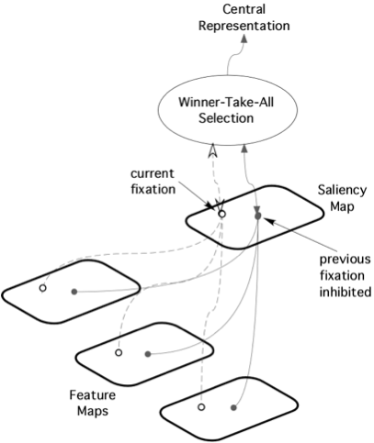

Fig.4  The Saliency Map Model as originally conceived by Koch & Ullman 1985. (figure adapted from Koch & Ullman 1985)

* 1. Buttom-Up Approach

The core of visual saliency is a bottom-up, stimulus-driven signal that announces “this location is sufficiently different from its surroundings to be worthy of your attention”. This *bottom-up* deployment of attention towards salient locations can be strongly modulated or even sometimes overridden by *top-down,* user-driven factors [20] [21]. Thus, a lone red object in a green field will be salient and will attract attention in a bottom-up manner.

* 1. Top-Down Approach

On the other hand, if you are looking through a child’s toy bin for a red plastic dragon, amidst plastic objects of many vivid colors, no one color may be especially salient until your top-down desire to find the red object renders all red objects, whether dragons or not, more salient.

1. General Computational Framework

A simple framework to think about how saliency may be computed in biological brains has been developed over the past three decades (Treisman & Gelade, 1980 [22]; Koch & Ullman, 1985 [2]; Niebur & Koch, 1996 [23]; Itti & Koch, 2001 [21]). According to the framework, incoming visual information is first analyzed by early visual neurons, which are sensitive to the various elementary visual features of the stimulus. This analysis, operated in parallel over the entire visual field and at multiple spatial and temporal scales, gives rise to a number of cortical *feature maps,* where each map represents the amount of a given visual feature at any location in the visual field. Within each of the feature maps, locations which significantly differ from their neighbors are highlighted, as further discussed below. Finally, all highlighted locations from all feature maps combine into a single saliency map which represents a pure saliency signal that is independent of visual features (Koch & Ullman, 1985 [2]; Nothdurft, 2000 [24]). According to several models, the relative contributions of different feature maps to the final saliency map is dependent upon the current behavioral goals and subjective state of the observer (Wolfe, 1994 [25]; Navalpakkam & Itti, 2005 [26]). In the absence of any particular task, such as, for example, during casual viewing, attention is drawn towards the most salient locations in the saliency map, as detected, for example, via a winner-take-all mechanism (Didday, 1976 [27]; Koch & Ullman, 1985 [2]). This, in turns, triggers motor actions which direct the eyes and the head towards salient visual locations (Dominey & Arbib, 1992 [28]; Findlay & Walker, 1999 [29]). Note that a number of theories exist as to whether an explicit saliency map is necessary or not (Hamker 1999 [30]; Li, 2002 [31]; see Saliency Map for additional discussion).

1. Proposed Computational Mechanisms
   1. A Model of Saliency-based Visual Attention for Rapid Scene Analysis--L. Itti, C. Koch and Ernst Niebur(1998) [11]

Inspired by the behavior and the neuronal architecture of the early primate visual system, the model combined multi-scale image features into a single topographical saliency map. This is a completely buttom-up approach.

* + 1. Architecture of Model

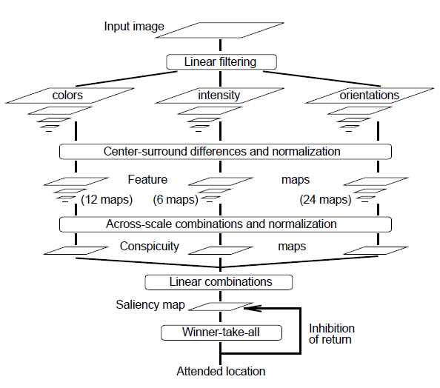

Fig.5 The architecture of Itti & Kuch model. (figure adapted from L. Itti, C. Koch and Ernst Niebur(1998))

* + 1. Visual Preprocessing

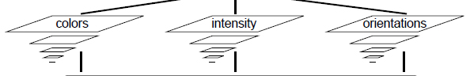

Fig.6

Define

$I= \frac{r+g+b}{3}$ (r,g,b are the color values).

For each pixel in the pyramid, generate the three color channels:

R = r-(g+b)/2

G = g-(r+b)/2

B = b-(r+g)/2

Four Gaussian pyramids $R\left(σ\right), G\left(σ\right), B\left(σ\right), I(σ)$ are created from these color channels, where $σ∈[0..8]$ is the scale.

* + 1. Center-Surround Differences

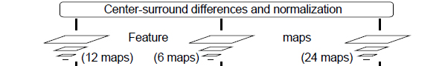

Fig.7

Each feature is computed by a set of linear“center-surround”operations. The concept is that typically visual neurons are most sensitive in a small region of the visual space (the center), while stimuli presented in a broader, weaker antagonistic region concentric with the center (the surround) inhibit the neuronal response. The operations is aimed at detecting locations which locally stand out from their surround.

Center-surround is implemented in the model as the difference between fine (center) and coarse (surround) scales: The center is a pixel at scale $c∈\{2,3,4\}$, and the surround is the corresponding pixel at scale $s=c+ δ, with δ∈\left\{3,4\right\}.$ Across-scale difference between two maps, denoted “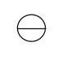”below, is obtained by interpolation to the finer scale and point-by-point subtraction.

|  |
| --- |
| Fig.8 |
| Fig. Achieve center-surround difference through across-scale difference  The first set of feature maps is concerned with intensity contrast, which in mammals is detected by neurons sensitive either to dark centers on bright surrounds, or to bright centers on dark surrounds. Both types of sensitivities are simultaneously computed in a set of six maps I(c,s): |

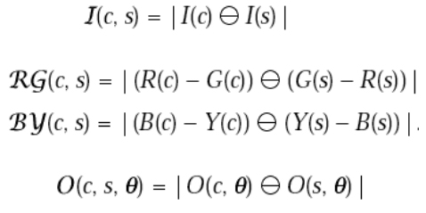(1)

The second set of maps is similarly constructed for the color channels, which in cortex are represented using a so-called “color double-opponent”system: In the center of their receptive field, neurons are excited by one color (e.g., red) and inhibited by another (e.g., green), while the converse is true in the surround. Such spatial and chromatic opponency exists for the red/green, green/red, blue/yellow and yellow/blue color pairs in human primary visual cortex. Accordingly, maps *RG(c,s)* (for red/green, green/red double opponency) and *BY(c,s)* (for blue/yellow, yellow/blue double oppenency) are created as Eq.2 and Eq.3.

(2),(3)

Local orientation is obtained from I using oriented Gabor pyramids $O(σ,θ)$, where $σ ∈[0..8]$ represents the scale and $θ ∈ \left\{0°,45°,90°,135°\right\}$ is the preferred orientation. Orientation feature maps, $O\left(c, s, θ\right)$, encode, as a group, local orientation contrast between the center and surround scales:

(4)

In total, 42 feature maps are computed: for intensity, 12 for color and 24 for orientation.

* + 1. Normalization

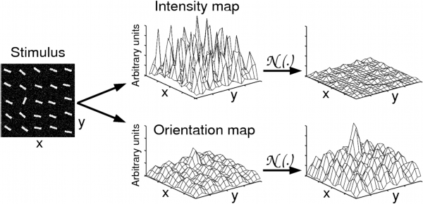

Fig.9

The operator is denoted as N(.). Normalize the values in the map to a fixed range [0..M] in order to eliminate modality-dependent amplitude differences. Find the location of the map’s global maximum M and compute the average $\overline{m}$ of all its other local maxima; and globally multiplying the map by .

* + 1. Conspicuity Maps

architecture03.jpg

Fig.10

The feature maps are combined into three conspicuity maps at the scale 4 ($σ=4$). $\overline{L} for intensity\left(Eq. \right), \overline{C} for color \left(Eq. \right), and \overline{O } for orientation (Eq.7)$ This is obtained through across-scale addition,“”, which consists of reducing of each map to scale 4 and point-by-point addition.

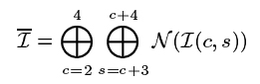(5)

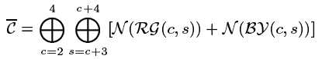(6)

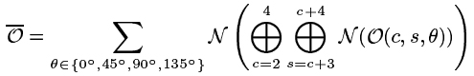(7)

* + 1. Saliency Map



Fig.11

The three conspicuity maps are normalized and summed into the final input S to the saliency map.

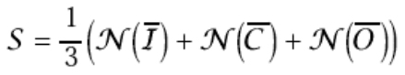(8)

* + 1. Example

|  |  |
| --- | --- |
| Original Image | |
| test.jpg | 2.jpg |
| **Saliency Map** | |
| test02.jpg | 2_02.jpg |
| Combine saliency map with original image | |
| test03.jpg  Table,2 | 2_03.jpg |

* 1. Graph-Based Visual Saliency(GBVS)

Jonathan Harel, Christof Koch and Pietro Perona(2007) [32]

The algorithm consists of two steps: first forming activation maps on certain feature channels, and then normalizing them in a way which highlights conspicuity and admits combination with other maps. The model is simple, and biologically plausible insofar as it is naturally parallelized. This model predicts human fixations more powerfully than the classical algorithms of Itti & Koch [11] [12] [15].

The leading models of visual saliency may be organized into the these three stages:

(s1) extraction: extract feature vectors at locations over the image plane

(s2) activation: form an "activation map" (or maps) using the feature vectors

(s3) normalization/combination: normalize the activation map (or maps, followed by a combination of the maps into a single map)

* + 1. Forming an Activation Map(s2)
       1. A Markovian Approach

Define the dissimilarity of *M(i,j)* and *M(p,q)* as

$$d((i,j)||(p,q))≜\left|\log{\frac{M(i,j)}{M(p,q)}}\right|$$

Consider now the fully-connected directed graph $G_{A}$, obtained by connecting every node of the lattice M, labelled with two indices $\left(i,j\right)∈{\left[n\right]}^{2}$, with all other n-1 nodes. The directed edge from node (i,j) to node (p,q) will be assigned a weight

$$w1\left(\left(i,j\right),\left(p,q\right)\right)≜ d((i,j)|\left|\left(p,q\right)\right)∙F\left(i-p,j-q\right), where$$

$$F\left(a,b\right)≜exp\left(-\frac{a^{2}+b^{2}}{2σ^{2}}\right)$$

$σ$ is a free parameter in the algorithm which has no significant effect on results. Thus, the weight of the edge from node (i, j) to node (p, q) is proportional to their dissimilarity and to their closeness in the domain of M. Note that the edge in the opposite direction has exactly the same weight. We may now dene a Markov chain on $G_{A}$ by normalizing the weights of the outbound edges of each node to 1, and drawing an equivalence between nodes & states, and edges weights & transition probabilities. The equilibrium distribution of this chain, reflecting the fraction of time a random walker would spend at each node/state if he were to walk forever, would naturally accumulate mass at nodes that have high dissimilarity with their surrounding nodes, since transitions into such subgraphs is likely, and unlikely if nodes have similar M values. The result is an activation measure which is derived from pairwise contrast.

We call this approach organic" because, biologically, individual “nodes”(neurons) exist in a connected, retinotopically organized, network (the visual cortex), and communicate with each other (synaptic ring) in a way which gives rise to emergent behavior, including fast decisions about which areas of a scene require additional processing. Similarly, our approach exposes connected (via F) regions of dissimilarity (via w), in a way which can in principle be omputed in a completely parallel fashion. Computations can be carried out independently at each node: in a synchronous environment, at each time step, each node simply sums incoming mass, then passes along measured partitions of this mass to its neighbors according to outbound edge weights. The same simple process happening at all nodes simultaneously gives rise to an equilibrium distribution of mass.

* + 1. Normalizing an Activation Map (s3)

The aim of the "normalization" step of the algorithm is much less clear than that of the activation step. It is, however, critical and a rich area of study. Earlier, three separate approaches were mentioned as existing benchmarks, and also the recent work of Itti on surprise [4] comes into the saliency computation at this stage of the process (although it can also be applied to s2 as mentioned above).

We shall state the goal of this step as: *concentrating mass on activation maps*. If mass is not concentrated on individual activation maps prior to additive combination, then the resulting master map may be too nearly uniform and hence uninformative. Although this may seem trivial, it is on some level the very soul of any saliency algorithm: concentrating activation into a few key locations.

Armed with the mass-concentration definition, we propose another Markovian algorithm as follows: This time, we begin with an activation map $A:{\left[n\right]}^{2}→R$, which we wish to“normalize”. We construct a graph $G_{N}$ with $n^{2}$ nodes labelled with indices from ${\left[n\right]}^{2}$. For each node (i, j) and every node (p, q) (including (i, j)) to which it is connected, we introduce an edge from (i, j) to (p, q) with weight:

Again, normalizing the weights of the outbound edges of each node to unity and treating the resulting graph as a Markov chain gives us the opportunity to compute the equilibrium distribution over the nodes. Mass will flow preferentially to those nodes with high activation. It is a mass concentration algorithm by construction, and also one which is parallelizable, as before, having the same natural advantages. Experimentally, it seems to behave very favorably compared to the standard approaches such as "DoG" and "NL".

* + 1. Example

|  |  |
| --- | --- |
| Original Image | |
| test.jpg | 2.jpg |
| **Saliency Map** | |
| gbvs_test02.jpg | 2_gbvs_02.jpg |
| Combine saliency map with original image | |
| gbvs_test03.jpg | 2_gbvs_03.jpg |

Table 3

1. Applications

Beyond the original application of the saliency map as the stage of a control system for covert attention, it has found use in other, related areas. Perhaps the most immediate extension is to predict eye movements [33] [34]. There are numerous technical applications in which the saliency map is typically used to prioritize selection, e.g. to identify the most important information in visual input streams and to use this to improve performance in generating or transmitting visual data [33]. Even an "inverse" saliency map has been used, to de-emphasize salient image regions and to direct attention to other regions [35]. Another original application of saliency maps is to generate synthetic vision for simulated actors in virtual environments [36]. Saliency maps have also been integrated in a VLSI hardware model of visual selective attention (Indiveri 2000 [37]).

1. Reference
2. J. K. Tsotsos (1991). Is Complexity Theory appropriate for analysing biological systems? Behavioral and Brain Sciences 14(4):770-773.
3. A. Treisman G. & Gelade (1980). A feature integration theory of attention. Cognitive Psychology 12:97-136.
4. F. Crick (1984). Function of the thalamic reticular complex: the searchlight hypothesis. Proceedings of the National Academies of Sciences USA 81(14):4586-90.
5. E. Weichselgartner & G. Sperling (1987). Dynamics of automatic and controlled visual attention. Science 238:778-780.
6. J. M. Wolfe (1994). Guided Search 2.0: A Revised Model of Visual Search. Psychonomic Bulletin & Review 1(2):202-238.
7. Tsakanikos, E. (2004). Latent inhibition, visual pop-out and schizotypy: is disruption of latent inhibition due to enhanced stimulus salience, *Personality and Individual Differences*, 37, 1347-1358.
8. Kapur, S. (2003). Psychosis as a state of aberrant salience: a framework linking biology, phenomenology, and pharmacology in schizophrenia. *American Journal of Psychiatry*,160, 13–23
9. Koch, C. and Ullman, S. Shifts in selective visual attention: towards the underlying neural circuitry. Human Neurobiology 4:219-227 (1985).
10. Clark, J.J., Ferrier, N. (1988). Modal control of an attentive vision system. Proc. ICCV, Tarpon Springs Florida, p514–523.
11. Sandon, P. (1990). Simulating visual attention, J. Cognitive Neuroscience 2, p213-231.
12. Itti, L., C. Koch, et al. (1998). A model of saliency-based visual attention for rapid scene analysis, IEEE Transactions on Pattern Analysis and Machine Intelligence 20(11), p1254-1259.
13. Itti, L., Koch, C. (2000). A saliency-based search mechanism for overt and covert shifts of visual attention, Vision Res 40(10-12), p1489-506
14. Walther, D., L. Itti, et al. (2002). Attentional selection for object recognition - A gentle way. Biologically Motivated Computer Vision, Proceedings 2525, p472-479.
15. Navalpakkam V, Itti L. (2005). Modeling the influence of task on attention, Vision Res. 45(2), p205-31.
16. Itti, L., Baldi, P. (2006). Bayesian Surprise Attracts Human Attention. Advances in Neural Information Processing Systems 18, 547–554.
17. Humphreys, G., Müller, H., (1993). Search via Recursive Rejection (SERR): A Connectionist Model of Visual Search, Cognitive Psychology, 25, p45 - 110.
18. Zhang, L., Tong, M. H., Marks, T.K., Shan, H., & Cottrell, G.W. (2008). SUN: A Bayesian framework for saliency using natural statistics. Journal of Vision, 8(7):32, p1–20.
19. Bruce, N.D.B., Tsotsos, J.K. (2009). Saliency, Attention, and Visual Search: An Information Theoretic Approach, Journal of Vision 9:3, p1-24.
20. Tsotsos, J.K., Itti, L., Rees, G. (2005). A Brief and Selective History of Attention, in Neurobiology of Attention, Editors Itti, Rees & Tsotsos, Elsevier Press, 2005
21. Desimone, R., Duncan, J. (1995). Neural mechanisms of selective visual attention, Ann. Rev. of Neuroscience 18, p193-222.
22. Itti, L., Koch, C. (2001), Computational modeling of visual attention, Nature Reviews Neuroscience 2, p 1-11.
23. Treisman, A., Gelade, G. (1980). A feature integration theory of attention, Cognitive Psychology 12, p97-136.
24. Usher, M., Niebur, E. (1996). Modeling the temporal dynamic of IT neurons in visual search: A mechanism for top-down selective attention, J. Cognitive Neuroscience 8:4, p311-327.
25. Nothdurft, H.C. Salience from feature contrast: variations with texture density. Vision Research **40** (2000)
26. J. M. Wolfe (1994). Guided Search 2.0: A Revised Model of Visual Search. Psychonomic Bulletin & Review 1(2):202-238.
27. V. Navalpakkam & L. Itti (2005). Modeling the influence of task on attention, Vision Research 45(2):205-231.
28. R. L. Didday (1976). A model of visuomotor mechanisms in the frog optic tectum. Mathematical Biosciences 30:169-180.
29. P. F. Dominey & M. A. Arbib (1992). A cortico-subcortical model for generation of spatially accurate sequential saccades. Cerebral Cortex 2(2):153-175.
30. J. M. Findlay & R. Walker, R (1999). A model of saccade generation based on parallel processing and competitive inhibition. Behavioral and Brain Sciences 22:661-674.
31. F.H. Hamker (1999). The role of feedback connections in task-driven visual search, in: D. Heinke, G.W. Humphreys, A. Olson (Eds.), Connectionist Models in Cognitive Neuroscience. Springer Verlag. London, pp. 252-261.
32. Li Z (2002). A saliency map in primary visual cortex Trends in Cognitive Sciences 6(1): 9-16.
33. D. Parkhurst, K. Law, & E. Niebur (2002). Modeling the role of salience in the allocation of overt visual attention. Vision Research 42(1):107-123.
34. Underwood, G., Foulsham, T, van Loon, E., Humphreys, L. and Bloyce, J.. Eye movements during scene inspection: A test of the saliency map hypothesis. European Journal Of Cognitive Psychology 18(3):321-342 (2006)
35. Su, S. L., Durand, F. and Agrawala, M. An Inverted Saliency Model for Display Enhancement. In Proceedings of 2004 MIT Student Oxygen Workshop, Ashland, MA (2004)
36. Courty, N. and Marchand, E. Visual perception based on salient features. Proc. of 2003 IEEE/RSJ Intl. Conference on Intelligent Robots and Systems. Las Vegas, Nevada 2003
37. Indiveri G. Modeling selective attention using a neuromorphic analog VLSI device. Neural Computation 12(12):2857-80 (2000)
38. Robinson, D. L. and Petersen, S. E. The pulvinar and visual salience. Trends Neuroscience 15(4):127-132 (1992)
39. Laurent Itti . Visual Salience. Retrieved June 27, 2012, from http://www.scholarpedia.org
40. Ernst Niebur. Saliency Map. Retrieved June 27, 2012, from http://www.scholarpedia.org
41. Salience (neuroscience). Retrieved June 27, 2012, from http://en.wikipedia.org