DISCUSSION OF RESULTS

It has been made analyses to the MOS between experiments where there are at the same settings among videos. For example, Exp1 and Exp3 have original and packet loss video settings in common, and so on. Considering only the original video settings, Pearson correlation between Exp1 and Exp3 was r = .386. Between Exp1 and Exp2; and Exp2 and Exp3, r<.2. To blurriness and packet loss video settings (in separately), r>.84. To blockiness video settings, r=.482. When it have been verified the correlation between experiments considering the subset of conditions shared by experiments, for example, “original + blockiness”, and so on, all correlation (r) was higher than .94.

The T-Test tests have been run considering:

A. GROUP: common video settings between experiments, i.e., “original + packet loss”, “original + blockiness”, “original + blurriness” and “original + blockiness + blurriness”;

B. PER VIDEO: all settings to one video, i.e., taking into account “original + packet loss” settings to the Park Joy, and so on;

C. ISOLATED: from one specific setting, for example, “original + artefact”, it was analysed the original and artefact videos, separately. For example, let us consider the Park Joy video where the T-Test test was run in the original and in the packet loss video, separately.

The T-Test test indicated that:

1. GROUP: there was no statistically significant difference between Scores for the “original + blurriness” setting. To all other cases (listed in (A)), were statistically significant.

2. PER VIDEO: there was no statistically significant difference between Scores for the cases tested from (A). However, considering “original + blurriness” and “original + blurriness + blockiness” settings for the Romeo & Juliet video was statistically significant.

3. ISOLATED: there was not statistically significant difference among the tests. Except to “original + packet loss”, setting across all videos (i.e., across all seven different videos), “original + blurriness” setting for Romeo & Juliet, Cactus and Basketball videos, and “Original + blurriness + blockiness” setting for Romeo & Juliet.

Analysing results of all experiments

1 – Analysing taking into account MOS (Mean Opinion Score)

* Case 1: considering only original videos (Exp.1, 2 e 3)
  + Correlation: A Pearson's correlation was run to assess the relationship between MOS in Exp1, Exp2 and Exp3. The table below shows the correlation coefficients between MOS across all experiments. There was not statistically significance difference among the results.

|  |  |  |
| --- | --- | --- |
|  | MOS2 | MOS3 |
| MOS1 | -.026 | .382 |
| MOS2 |  | .008 |

Note: * statistically significant at p<.05 level

* + T-Test

A Mann-Whitney U test was run to determine if there were differences in MOS among the experiments. Distributions of the MOS for Exp1 and Exp2 were similar and, median MOS was statistically significantly higher in Exp2 (10.71) than in Exp1 (4.29), U = 2, z = -2.875, p = .004. The distributions of the MOS for Exp2 and Exp3 also were similar with median MOS statistically significantly higher in Exp2 (11.00) than in Exp3 (4.00), U = .0, z = -3.134, p = .002. Mann-Whitney U distributions of the MOS for Exp1 and Exp3 were similar but, median MOS for Exp1 (8.29) and Exp3 (6.71) was not statistically significantly different, U = 19, z = -0.706, p = .480.

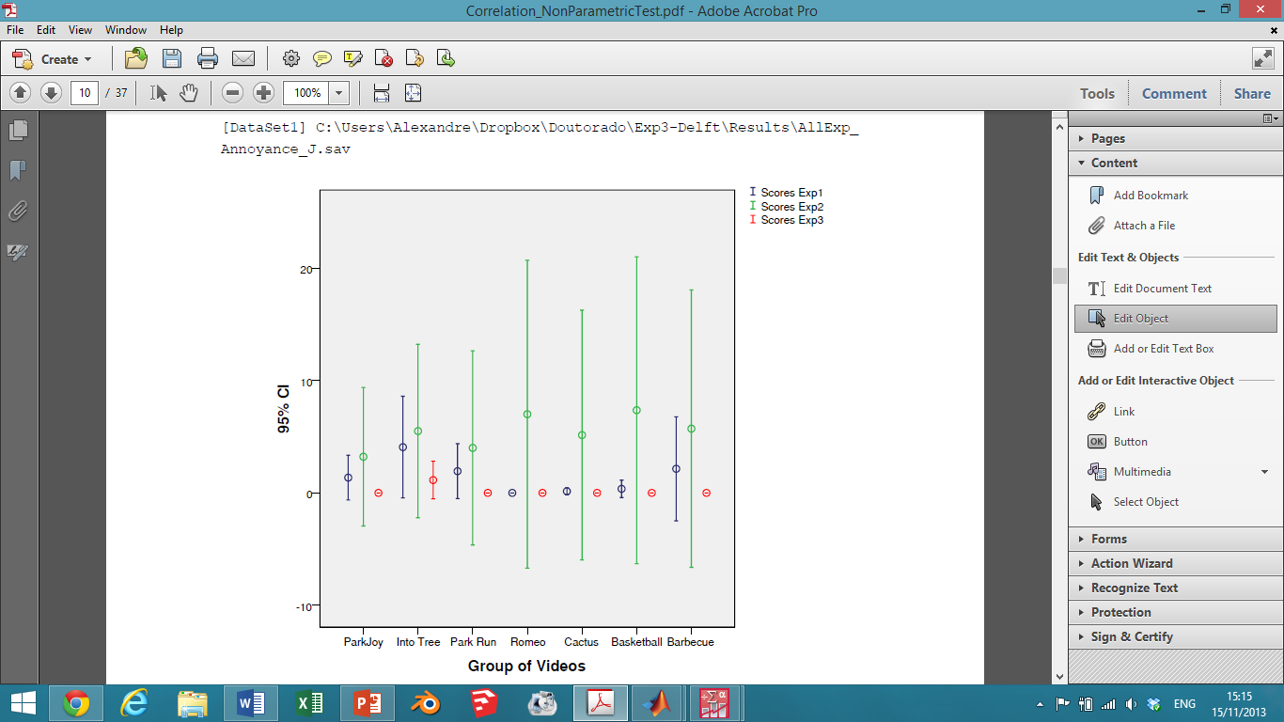

* Case 2.1: considering only *packet loss* (Exp. 1 e 3)
  + Correlation: A Pearson's correlation was run to assess the relationship between MOS in Exp1 and Exp3. There was a strong positive correlation between MOS1 and MOS3, r = .842, p = .018 with MOS1 explained 71% of the variability in MOS3.
  + T-Test

A Mann-Whitney U test was run to determine if there were differences in MOS among the experiments. Distributions of the MOS for Exp1 and Exp3 were similar and, median MOS was statistically significantly higher in Exp1 (10.57) than in Exp3 (4.43), *U* = 3, *z* = -2.747, *p* = .006.

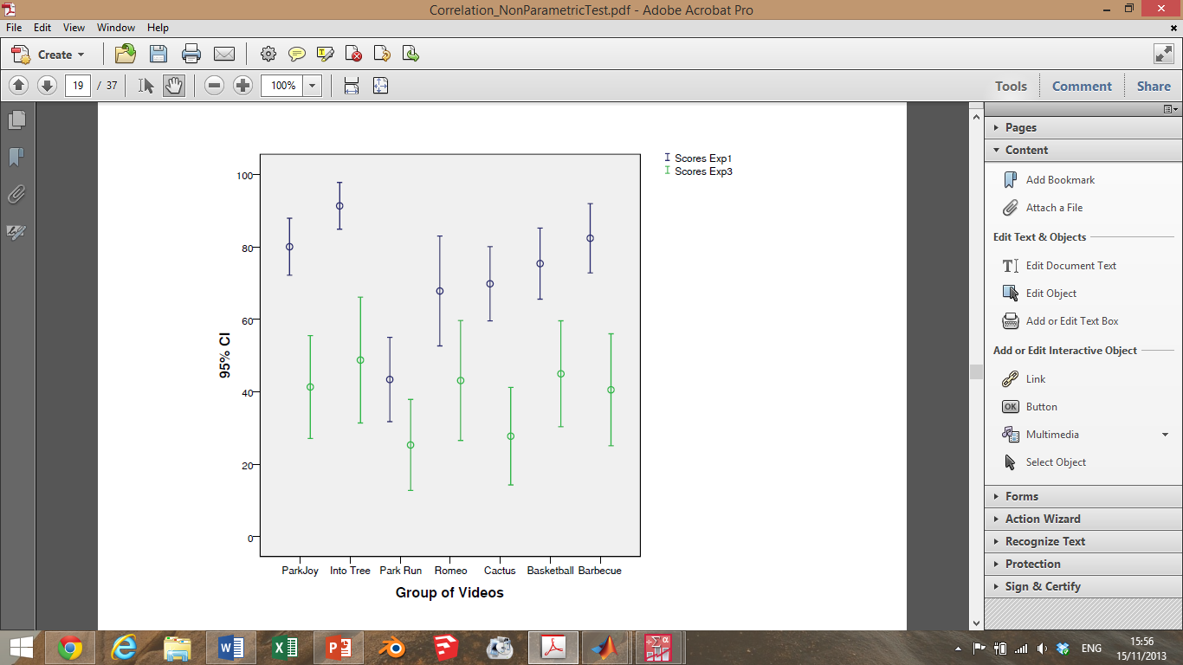

* Case 2.2: considering only *blockiness* (Exp. 2 e 3)
  + Correlation: A Pearson's correlation was run to assess the relationship between MOS in Exp2 and Exp3. There was a moderate positive correlation between MOS2 and MOS3, r = .482, p = .274 with MOS1 explained 23% of the variability in MOS3.
  + T-Test

A Mann-Whitney U test was run to determine if there were differences in MOS among the experiments. Distributions of the MOS for Exp2 and Exp3 were similar and, median MOS was statistically significantly in Exp2 (9.86) than in Exp3 (5.14), U = 8, z = -2.108, p = .035.

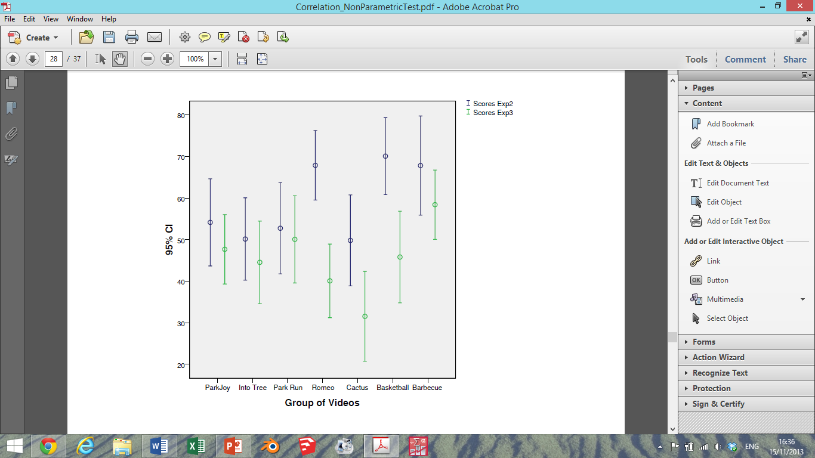

* Case 2.3: considering only *blurriness* (Exp. 2 e 3)
  + Correlation: A Pearson's correlation was run to assess the relationship between MOS in Exp2 and Exp3. There was a strong positive correlation between MOS2 and MOS3, r = .872, p = .011 with MOS2 explained 76% of the variability in MOS3.
  + T-Test

A Mann-Whitney U test was run to determine if there were differences in MOS among the experiments. Distributions of the MOS for Exp2 and Exp3 were similar and, median MOS was equal (it is not statistically significantly) in Exp2 (7.50) and Exp3 (7.50), U = 24.50, z = .000, p = 1.

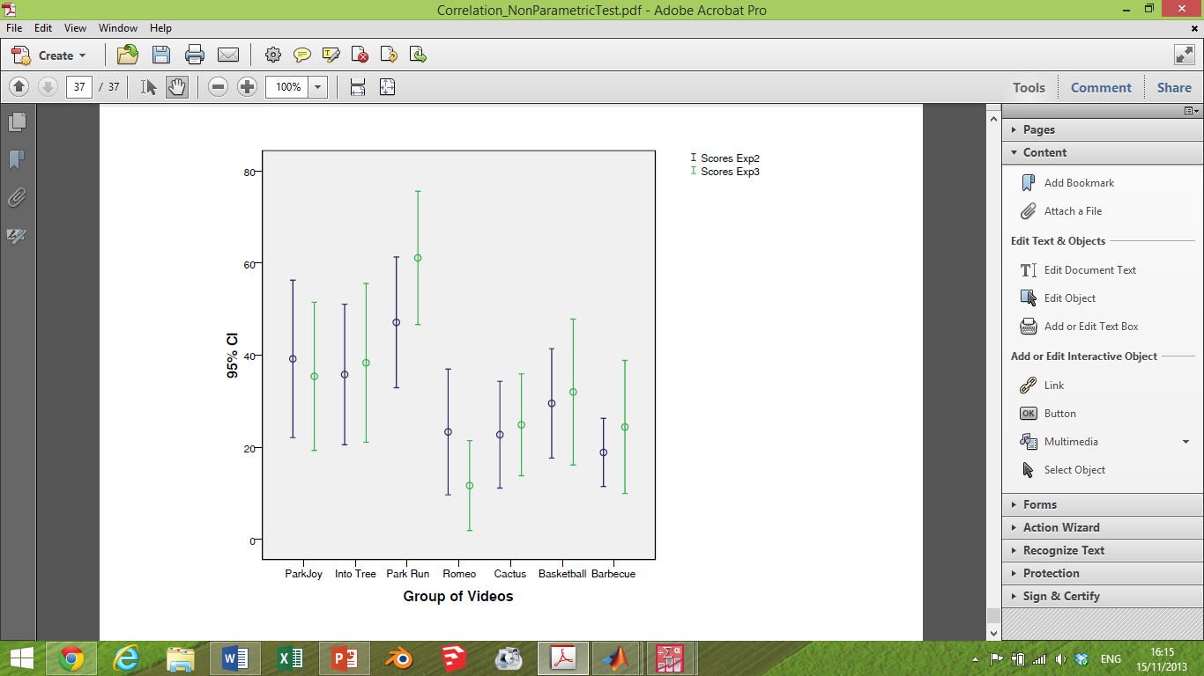

* Case 3: considering videos groups: *original + packet loss* (Exp. 1 e 3)
  + Correlation: A Pearson's correlation was run to assess the relationship between MOS in Exp1 and Exp3. There was a strong positive correlation between MOS1 and MOS3, r = .983, p < .001 with MOS1 explained 97% of the variability in MOS3.
  + T-Test
    - A Mann-Whitney U test was run to determine if there were differences in MOS between Exp1 and Exp3 considering the group of original and packet loss videos. Median MOS was not statistically significantly in Exp1 (16.43) than in Exp3 (12.57), U = 71, z = -1.241, p = .215.
* Case 4: considering videos groups: *original + blockiness* (Exp. 2 e 3)
  + Correlation: A Pearson's correlation was run to assess the relationship between MOS in Exp2 and Exp3. There was a strong positive correlation between MOS1 and MOS3, r = .975, p < .001 with MOS2 explained 95% of the variability in MOS3.
  + T-Test
    - A Mann-Whitney U test was run to determine if there were differences in MOS between Exp2 and Exp3 to all videos (original and blockiness). Median MOS was not statistically significantly in Exp2 (17.43) than in Exp3 (11.57), U = 57, z = -1.884, p = .060.
* Case 5: considering videos groups: *original + blurriness* (Exp. 2 e 3)
  + Correlation: A Pearson's correlation was run to assess the relationship between MOS in Exp2 and Exp3. There was a strong positive correlation between MOS1 and MOS3, r = .967, p < .001 with MOS2 explained 94% of the variability in MOS3.
  + T-Test
    - A Mann-Whitney U test was run to determine if there were differences in MOS between Exp2 and Exp3 to all videos (original and blurriness). Median MOS was not statistically significantly in Exp2 (16.25) than in Exp3 (12.75), U = 73.50, z = -1.126, p = .260.
* Case 6: considering videos groups: *original + blockiness + blurriness* (Exp. 2 e 3)
  + Correlation: A Pearson's correlation was run to assess the relationship between MOS in Exp2 and Exp3. There was a strong positive correlation between MOS2 and MOS3, r = .940, p < .001 with MOS2 explained 88% of the variability in MOS3.
  + T-Test
    - A Mann-Whitney U test was run to determine if there were differences in MOS between Exp2 and Exp3 to all videos (original, blockiness and blurriness). Median MOS was not statistically significantly in Exp2 (23.50) than in Exp3 (19.50), U = 178.50, z = -1.057, p = .291.

Analysing results of all experiments

1 – Analysing taking into account Scores

* Case 1: considering videos groups: *original + packet loss* (Exp. 1 e 3)
  + T-Test
    - All videos in the group

A Mann-Whitney U test was run to determine if there were differences in scores between Exp1 and Exp3 to all videos in the group (i.e, original and packet loss). Median scores was statistically significantly in Exp1 (292.11) than in Exp3 (239.65), U = 25164, z = -4.0.86, p < .001.

* + - Per video
      * Park Joy

A Mann-Whitney U test was run to determine if there were differences in scores between Exp1 and Exp3 to Park Joy (original). Median scores was not statistically significantly in Exp1 (43.23) than in Exp3 (34.01), U = 483.50, z = -1.892, p = .059.

* + - * Into Tree

A Mann-Whitney U test was run to determine if there were differences in scores between Exp1 and Exp3 to Into Tress (packet loss). Median scores was not statistically significantly in Exp1 (43.52) than in Exp3 (33.84), U = 475.50, z = -1.952, p = .051.

* + - * Park Run

A Mann-Whitney U test was run to determine if there were differences in scores between Exp1 and Exp3 to Park Joy (original and packet loss). Median scores was not statistically significantly in Exp1 (42.55) than in Exp3 (34.42), U = 502.50, z = -1.661, p = .097.

* + - * Romeo & Juliet

A Mann-Whitney U test was run to determine if there were differences in scores between Exp1 and Exp3 to Into Tress (original and packet loss). Median scores was not statistically significantly in Exp1 (40.68) than in Exp3 (35.57), U = 555, z = -1.067, p = .286.

* + - * Cactus

A Mann-Whitney U test was run to determine if there were differences in scores between Exp1 and Exp3 to Park Joy (original and packet loss). Median scores was not statistically significantly in Exp1 (42.64) than in Exp3 (34.37), U = 500, z = -1.698, p = .090.

* + - * Basketball

A Mann-Whitney U test was run to determine if there were differences in scores between Exp1 and Exp3 to Into Tress (original and packet loss). Median scores was not statistically significantly in Exp1 (41.70) than in Exp3 (34.95), U = 526.50, z = -1.385, p = .166.

* + - * Barbecue

A Mann-Whitney U test was run to determine if there were differences in scores between Exp1 and Exp3 to Park Joy (original and packet loss). Median scores was not statistically significantly in Exp1 (42.48) than in Exp3 (34.47), U = 504.50, z = -1.644, p = .100.

* + - Comparing between videos (i.e, original vs Packet Loss)
      * Park Joy

A Mann-Whitney U test was run to determine if there were differences in scores between Exp1 and Exp3 to Park Joy (original). Median scores was not statistically significantly in Exp1 (20.64) than in Exp3 (18), U = 138, z = -1.838, p = .066. A Mann-Whitney U test was run to determine if there were differences in scores between Exp1 and Exp3 to Park Joy (packet loss). Median scores was statistically significantly higher in Exp1 (28.68) than in Exp3 (13.11), U = 25.50, z = -4.245, p < .001.

* + - * Into Tree

A Mann-Whitney U test was run to determine if there were differences in scores between Exp1 and Exp3 to Park Joy (original). Median scores was not statistically significantly in Exp1 (21.43) than in Exp3 (17.52), U = 127, z = -1.659, p = .097. A Mann-Whitney U test was run to determine if there were differences in scores between Exp1 and Exp3 to Park Joy (packet loss). Median scores was statistically significantly higher in Exp1 (28.11) than in Exp3 (13.46), U = 33.50, z = -4.008, p < .001.

* + - * Park Run

A Mann-Whitney U test was run to determine if there were differences in scores between Exp1 and Exp3 to Park Joy (original). Median scores was not statistically significantly in Exp1 (20.36) than in Exp3 (18.17), U = 142, z = -1.001, p = .317. A Mann-Whitney U test was run to determine if there were differences in scores between Exp1 and Exp3 to Park Joy (packet loss). Median scores was statistically significantly higher in Exp1 (25.86) than in Exp3 (14.83), U = 65, z = -3.012, p = .003.

* + - * Romeo & Juliet

A Mann-Whitney U test was run to determine if there were differences in scores between Exp1 and Exp3 to Park Joy (original). Median scores was not statistically significantly in Exp1 (19) than in Exp3 (19), U = 161, z = -.000, p = 1.000. A Mann-Whitney U test was run to determine if there were differences in scores between Exp1 and Exp3 to Park Joy (packet loss). Median scores was statistically significantly higher in Exp1 (24.86) than in Exp3 (15.43), U = 79, z = -2.570, p = .010.

* + - * Cactus

A Mann-Whitney U test was run to determine if there were differences in scores between Exp1 and Exp3 to Park Joy (original). Median scores was not statistically significantly in Exp1 (19.29) than in Exp3 (18.83), U = 157, z = -.320, p = .749. A Mann-Whitney U test was run to determine if there were differences in scores between Exp1 and Exp3 to Park Joy (packet loss). Median scores was statistically significantly higher in Exp1 (29) than in Exp3 (12.91), U = 21, z = -4.392, p < .001.

* + - * Basketball

A Mann-Whitney U test was run to determine if there were differences in scores between Exp1 and Exp3 to Park Joy (original). Median scores was not statistically significantly in Exp1 (19.29) than in Exp3 (18.83), U = 157, z = -.320, p = .749. A Mann-Whitney U test was run to determine if there were differences in scores between Exp1 and Exp3 to Park Joy (packet loss). Median scores was statistically significantly higher in Exp1 (27.11) than in Exp3 (14.07), U = 47.50, z = -3.557, p < .001.

* + - * Barbecue

A Mann-Whitney U test was run to determine if there were differences in scores between Exp1 and Exp3 to Park Joy (original). Median scores was not statistically significantly in Exp1 (19.29) than in Exp3 (18.83), U = 157, z = -.320, p = .749. A Mann-Whitney U test was run to determine if there were differences in scores between Exp1 and Exp3 to Park Joy (packet loss). Median scores was statistically significantly higher in Exp1 (28.11) than in Exp3 (13.46), U = 33.50, z = -3.997, p < .001.

* Case 2: considering videos groups: *original + blockiness* (Exp. 2 e 3)
  + T-Test
    - All videos in the group

A Mann-Whitney U test was run to determine if there were differences in scores between Exp2 and Exp3 to all videos (original and blockiness). Median scores was statistically significantly in Exp2 (294.17) than in Exp3 (259.12), U = 31435, z = -2.691, p = .007

* + - Per video
      * Park Joy

A Mann-Whitney U test was run to determine if there were differences in scores between Exp2 and Exp3 to Park Joy (original and blockiness). Median scores was not statistically significantly in Exp2 (41.16) than in Exp3 (38.35), U = 683.0, z = -.570, p = .569.

* + - * Into Tree

A Mann-Whitney U test was run to determine if there were differences in scores between Exp2 and Exp3 to Into Tress (original and blockiness). Median scores was not statistically significantly in Exp2 (42.47) than in Exp3 (37.43), U = 641, z = -1.000, p = .317.

* + - * Park Run

A Mann-Whitney U test was run to determine if there were differences in scores between Exp2 and Exp3 to Park Joy (original and blockiness). Median scores was not statistically significantly in Exp2 (39.77) than in Exp3 (39.32), U = 727.50, z = -.091, p = .928.

* + - * Romeo & Juliet

A Mann-Whitney U test was run to determine if there were differences in scores between Exp2 and Exp3 to Into Tress (original and blockiness). Median scores was not statistically significantly in Exp2 (44.67) than in Exp3 (35.90), U = 570.50, z = -1.779, p = .075.

* + - * Cactus

A Mann-Whitney U test was run to determine if there were differences in scores between Exp2 and Exp3 to Park Joy (original and blockiness). Median scores was not statistically significantly in Exp2 (43.31) than in Exp3 (36.85), U = 614, z = -1.325, p = .185.

* + - * Basketball

A Mann-Whitney U test was run to determine if there were differences in scores between Exp2 and Exp3 to Into Tress (original and blockiness). Median scores was not statistically significantly in Exp2 (44.48) than in Exp3 (36.03), U = 576.50, z = -1.699, p = .089.

* + - * Barbecue

A Mann-Whitney U test was run to determine if there were differences in scores between Exp2 and Exp3 to Park Joy (original and blockiness). Median scores was not statistically significantly in Exp2 (41.97) than in Exp3 (37.78), U = 657, z = -.849, p = .396.

* + - Comparing between videos (i.e, original vs Blockiness)
      * Park Joy

A Mann-Whitney U test was run to determine if there were differences in scores between Exp2 and Exp3 to Park Joy (original). Median scores was not statistically significantly in Exp2 (21.44) than in Exp3 (19.00), U = 161, z = -1.718, p = .086. A Mann-Whitney U test was run to determine if there were differences in scores between Exp2 and Exp3 to Park Joy (blockiness). Median scores was not statistically significantly in Exp2 (21.13) than in Exp3 (19.22), U = 166, z = -.515, p = .607.

* + - * Into Tree

A Mann-Whitney U test was run to determine if there were differences in scores between Exp2 and Exp3 to Into Tree (original). Median scores was not statistically significantly in Exp2 (22.84) than in Exp3 (18.02), U = 138.50, z = -1.942, p = .052. A Mann-Whitney U test was run to determine if there were differences in scores between Exp2 and Exp3 to Into Tree (blockiness). Median scores was not statistically significantly in Exp3 (20.43) than in Exp2 (19.42), U = 173.50, z = -.300, p = .764.

* + - * Park Run

A Mann-Whitney U test was run to determine if there were differences in scores between Exp2 and Exp3 to Park Run (original). Median scores was not statistically significantly in Exp3 (20.15) than in Exp2 (19.78), U = 180.50, z = -.216, p = .829. A Mann-Whitney U test was run to determine if there were differences in scores between Exp2 and Exp3 to Park Run (blockiness). Median scores was not statistically significantly in Exp3 (21.91) than in Exp2 (17.25), U = 140, z = -1.258, p = .208.

* + - * Romeo & Juliet

A Mann-Whitney U test was run to determine if there were differences in scores between Exp2 and Exp3 to Romeo & Juliet (original). Median scores was not statistically significantly in Exp2 (21.44) than in Exp3 (19.00), U = 161, z = -1.718, p = .086. A Mann-Whitney U test was run to determine if there were differences in scores between Exp2 and Exp3 to Romeo & Juliet (blockiness). Median scores was not statistically significantly in Exp2 (23.72) than in Exp3 (17.41), U = 124.50, z = -1.774, p = .076.

* + - * Cactus

A Mann-Whitney U test was run to determine if there were differences in scores between Exp2 and Exp3 to Cactus (original). Median scores was not statistically significantly in Exp2 (20.25) than in Exp3 (19.83), U = 180, z = -.299, p = .765. A Mann-Whitney U test was run to determine if there were differences in scores between Exp2 and Exp3 to Cactus (blockiness). Median scores was not statistically significantly in Exp3 (20.61) than in Exp2 (18.69), U = 163, z = -.602, p = .547.

* + - * Basketball

A Mann-Whitney U test was run to determine if there were differences in scores between Exp2 and Exp3 to Basketball (original). Median scores was not statistically significantly in Exp2 (21.63) than in Exp3 (18.87), U = 158, z = -1.410, p = .159. A Mann-Whitney U test was run to determine if there were differences in scores between Exp2 and Exp3 to Basketball (blockiness). Median scores was not statistically significantly in Exp3 (20.11) than in Exp2 (19.84), U = 181.50, z = -.072, p = .943.

* + - * Barbecue

A Mann-Whitney U test was run to determine if there were differences in scores between Exp2 and Exp3 to Barbecue (original). Median scores was not statistically significantly in Exp2 (20.25) than in Exp3 (19.83), U = 180, z = -.299, p = .765. A Mann-Whitney U test was run to determine if there were differences in scores between Exp2 and Exp3 to Barbecue (blockiness). Median scores was not statistically significantly in Exp2 (20.47) than in Exp3 (19.67), U = 176.50, z = -.215, p = .830.

* Case 3: considering videos groups: *original + blurriness* (Exp. 2 e 3)
  + T-Test
    - All videos in the group

A Mann-Whitney U test was run to determine if there were differences in scores between Exp2 and Exp3 to all videos (original and blurriness). Median score was not statistically significantly in Exp2 (283.79) than in Exp3 (266.34), U = 33759, z = -1.384, p = .166.

* + - Per video
      * Park Joy

A Mann-Whitney U test was run to determine if there were differences in scores between Exp2 and Exp3 to Park Joy (original and blurriness). Median scores was not statistically significantly in Exp2 (41.31) than in Exp3 (38.24), U = 678, z = -.641, p = .521.

* + - * Into Tree

A Mann-Whitney U test was run to determine if there were differences in scores between Exp2 and Exp3 to Into Tree (original and blurriness). Median scores was not statistically significantly in Exp2 (41.11) than in Exp3 (38.38), U = 684.50, z = -.549, p = .583.

* + - * Park Run

A Mann-Whitney U test was run to determine if there were differences in scores between Exp2 and Exp3 to Park Run (original and blurriness). Median scores was not statistically significantly in Exp3 (40.67) than in Exp2 (37.81), U = 682, z = -.580, p = .562.

* + - * Romeo & Juliet

A Mann-Whitney U test was run to determine if there were differences in scores between Exp2 and Exp3 to Romeo & Juliet (original and blurriness). Median scores was statistically significantly in Exp2 (44.64) than in Exp2 (35.92), U = 571.50, z = -2.044, p = .041.

* + - * Cactus

A Mann-Whitney U test was run to determine if there were differences in scores between Exp2 and Exp3 to Cactus (original and blurriness). Median scores was not statistically significantly in Exp3 (39.75) than in Exp2 (39.14), U = 724.50, z = -.128, p = .898.

* + - * Basketball

A Mann-Whitney U test was run to determine if there were differences in scores between Exp2 and Exp3 to Basketball (original and blurriness). Median scores was not statistically significantly in Exp2 (42.03) than in Exp3 (37.74), U = 655, z = -.885, p = .376.

* + - * Barbecue

A Mann-Whitney U test was run to determine if there were differences in scores between Exp2 and Exp3 to Barbecue (original and blurriness). Median scores was not statistically significantly in Exp2 (40.94) than in Exp3 (38.50), U = 690, z = -.512, p = .608.

* + - Comparing between videos (i.e, original vs blurriness)
      * Park Joy

A Mann-Whitney U test was run to determine if there were differences in scores between Exp2 and Exp3 to Park Joy (original). Median scores was not statistically significantly in Exp2 (21.44) than in Exp3 (19.00), U = 161, z = -1.718, p = .086. A Mann-Whitney U test was run to determine if there were differences in scores between Exp2 and Exp3 to Park Joy (blurriness). Median scores was not statistically significantly in Exp2 (21.59) than in Exp3 (18.89), U = 158.50, z = -.730, p = .465.

* + - * Into Tree

A Mann-Whitney U test was run to determine if there were differences in scores between Exp2 and Exp3 to Into Tree (original). Median scores was not statistically significantly in Exp2 (22.84) than in Exp3 (18.02), U = 138.50, z = -1.942, p = .052. A Mann-Whitney U test was run to determine if there were differences in scores between Exp2 and Exp3 to Into Tree (blurriness). Median scores was not statistically significantly in Exp2 (21.97) than in Exp3 (18.63), U = 152.50, z = -.900, p = .368.

* + - * Park Run

A Mann-Whitney U test was run to determine if there were differences in scores between Exp2 and Exp3 to Park Run (original). Median scores was not statistically significantly in Exp3 (20.15) than in Exp2 (19.78), U = 180.50, z = -.216, p = .829. A Mann-Whitney U test was run to determine if there were differences in scores between Exp2 and Exp3 to Park Run (blurriness). Median scores was not statistically significantly in Exp2 (20.00) than in Exp3 (20.00), U = 184, z = .000, p = 1.000.

* + - * Romeo & Juliet

A Mann-Whitney U test was run to determine if there were differences in scores between Exp2 and Exp3 to Romeo & Juliet (original). Median scores was not statistically significantly in Exp2 (21.44) than in Exp3 (19.00), U = 161, z = -1.718, p = .086. A Mann-Whitney U test was run to determine if there were differences in scores between Exp2 and Exp3 to Romeo & Juliet (blurriness). Median scores was statistically significantly in Exp2 (27.47) than in Exp3 (14.80), U = 64.50, z = -3.415, p = .001.

* + - * Cactus

A Mann-Whitney U test was run to determine if there were differences in scores between Exp2 and Exp3 to Cactus (original). Median scores was not statistically significantly in Exp2 (20.25) than in Exp3 (19.83), U = 180, z = -.299, p = .765. A Mann-Whitney U test was run to determine if there were differences in scores between Exp2 and Exp3 to Cactus (blurriness). Median scores was statistically significantly in Exp2 (25.06) than in Exp3 (16.48), U = 103, z = -2.31, p = .020.

* + - * Basketball

A Mann-Whitney U test was run to determine if there were differences in scores between Exp2 and Exp3 to Basketball (original). Median scores was not statistically significantly in Exp2 (21.63) than in Exp3 (18.87), U = 158, z = -1.410, p = .159. A Mann-Whitney U test was run to determine if there were differences in scores between Exp2 and Exp3 to Basketball (blurriness). Median scores was statistically significantly in Exp2 (26.91) than in Exp3 (15.20), U = 73.50, z = -3.161, p = .002.

* + - * Barbecue

A Mann-Whitney U test was run to determine if there were differences in scores between Exp2 and Exp3 to Barbecue (original). Median scores was not statistically significantly in Exp2 (20.25) than in Exp3 (19.83), U = 180, z = -.299, p = .765. A Mann-Whitney U test was run to determine if there were differences in scores between Exp2 and Exp3 to Barbecue (blurriness). Median scores was not statistically significantly in Exp2 (23.59) than in Exp3 (17.50), U = 126.50, z = -1.644, p = .100.

* Case 4: considering videos groups: *original + blurriness + blockiness* (Exp. 2 e 3)
  + T-Test
    - All videos in the group

A Mann-Whitney U test was run to determine if there were differences in scores between Exp2 and Exp3 to all videos (original, blockiness and blurriness). Median score was statistically significantly in Exp2 (431.41) than in Exp3 (395.11), U = 73951.50, z = -2.213, p = .0.27.

* + - Per video

• Park Joy

A Mann-Whitney U test was run to determine if there were differences in scores between Exp2 and Exp3 to Park Joy. Median scores was not statistically significantly in Exp2 (61.43) than in Exp3 (57.31), U = 1539.50, z = -.661, p = .508.

• Into Tree

A Mann-Whitney U test was run to determine if there were differences in scores between Exp2 and Exp3 to Into Tree. Median scores was not statistically significantly in Exp2 (61.33) than in Exp3 (57.38), U = 1544, z = -.629, p = .529.

• Park Run

A Mann-Whitney U test was run to determine if there were differences in scores between Exp2 and Exp3 to Park Run. Median scores was not statistically significantly in Exp3 (60.33) than in Exp2 (57.08), U = 1564, z = -.518, p = .604.

• Romeo & Juliet

A Mann-Whitney U test was run to determine if there were differences in scores between Exp2 and Exp3 to Romeo & Juliet. Median scores was statistically significantly in Exp2 (66.85) than in Exp3 (53.54), U = 1279, z = -2.200, p = .028.

• Cactus

A Mann-Whitney U test was run to determine if there were differences in scores between Exp2 and Exp3 to Cactus. Median scores was not statistically significantly in Exp2 (62.18) than in Exp3 (56.79), U = 1503.50, z = -.871, p = .384.

• Basketball

A Mann-Whitney U test was run to determine if there were differences in scores between Exp2 and Exp3 to Basketball. Median scores was not statistically significantly in Exp2 (64.10) than in Exp3 (55.45), U = 1411, z = -1.386, p = .166.

• Barbecue

A Mann-Whitney U test was run to determine if there were differences in scores between Exp2 and Exp3 to Barbecue. Median scores was not statistically significantly in Exp2 (61.08) than in Exp3 (57.55), U = 1556, z = -.569, p = .570.

* + - Comparing between videos (i.e, original vs blockiness and blurriness)
      * Park Joy

A Mann-Whitney U test was run to determine if there were differences in scores between Exp2 and Exp3 to Park Joy (original). Median scores was not statistically significantly in Exp2 (21.44) than in Exp3 (19.00), U = 161, z = -1.718, p = .086. A Mann-Whitney U test was run to determine if there were differences in scores between Exp2 and Exp3 to Park Joy (blockiness, blurriness). Median scores was not statistically significantly in Exp2 (41.75) than in Exp3 (37.93), U = 664, z = -.732, p = .464.

* + - * Into Tree

A Mann-Whitney U test was run to determine if there were differences in scores between Exp2 and Exp3 to Into Tree (original). Median scores was not statistically significantly in Exp2 (22.84) than in Exp3 (18.02), U = 138.50, z = -1.942, p = .052. A Mann-Whitney U test was run to determine if there were differences in scores between Exp2 and Exp3 to Into Tree (blockiness, blurriness). Median scores was not statistically significantly in Exp2 (40.50) than in Exp3 (38.88), U = 704, z = -.325, p = .745.

* + - * Park Run

A Mann-Whitney U test was run to determine if there were differences in scores between Exp2 and Exp3 to Park Run (original). Median scores was not statistically significantly in Exp3 (20.15) than in Exp2 (19.78), U = 180.50, z = -.216, p = .829. A Mann-Whitney U test was run to determine if there were differences in scores between Exp2 and Exp3 to Park Run (blockiness, blurriness). Median scores was not statistically significantly in Exp3 (41.54) than in Exp2 (36.56), U = 642, z = .957, p = .339.

* + - * Romeo & Juliet

A Mann-Whitney U test was run to determine if there were differences in scores between Exp2 and Exp3 to Romeo & Juliet (original). Median scores was not statistically significantly in Exp2 (21.44) than in Exp3 (19.00), U = 161, z = -1.718, p = .086. A Mann-Whitney U test was run to determine if there were differences in scores between Exp2 and Exp3 to Romeo & Juliet (blockiness, blurriness). Median scores was statistically significantly in Exp2 (47.28) than in Exp3 (34.09), U = 487, z = -2.543, p = .011.

* + - * Cactus

A Mann-Whitney U test was run to determine if there were differences in scores between Exp2 and Exp3 to Cactus (original). Median scores was not statistically significantly in Exp2 (20.25) than in Exp3 (19.83), U = 180, z = -.299, p = .765. A Mann-Whitney U test was run to determine if there were differences in scores between Exp2 and Exp3 to Cactus (blockiness, blurriness). Median scores was not statistically significantly in Exp2 (42.81) than in Exp3 (37.20), U = 630, z = -1.079, p = .281.

* + - * Basketball

A Mann-Whitney U test was run to determine if there were differences in scores between Exp2 and Exp3 to Basketball (original). Median scores was not statistically significantly in Exp2 (21.63) than in Exp3 (18.87), U = 158, z = -1.410, p = .159. A Mann-Whitney U test was run to determine if there were differences in scores between Exp2 and Exp3 to Basketball (blockiness, blurriness). Median scores was not statistically significantly in Exp2 (43.84) than in Exp3 (36.49), U = 597.50, z = -1.408, p = .159.

* + - * Barbecue

A Mann-Whitney U test was run to determine if there were differences in scores between Exp2 and Exp3 to Barbecue (original). Median scores was not statistically significantly in Exp2 (20.25) than in Exp3 (19.83), U = 180, z = -.299, p = .765. A Mann-Whitney U test was run to determine if there were differences in scores between Exp2 and Exp3 to Barbecue (blockiness, blurriness). Median scores was not statistically significantly in Exp2 (40.88) than in Exp3 (38.54), U = 692, z = -.447, p = .655.