**VARIUM – Experiment 3: Multiple Artifacts**

The goal of the third experiment will be to unveil the annoyance brought about by overlaps of three different artifacts (Packet Loss, Blockiness and Blurriness).

To look into this, we will distort 7 pristine videos (already used in previous experiments [1]) with different combinations of the parameters regulating the amount of Packet Loss, Blurriness and Blockiness.

As creating a full factorial design with all the parameters involved in the previous experiments would have been prohibitive, we operated a selection of those parameters based on the results of experiments 1 and 2.

For example, in experiment 1 for packet loss we had considered 2 different types of parameters: the number of frames in which the video was encoded (3 settings), and the percentage of lost packets per video (4 settings). We decided to use in this new experiment a single setting for the number of video frames (I12), being it the most realistic setting. To select the settings for the percentages of lost packets, we looked at the averages of the Mean Annoyance Values and Mean Strength Values obtained across videos encoded in I12 for each parameter setting:

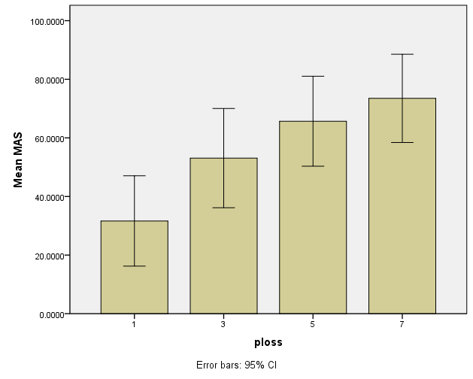 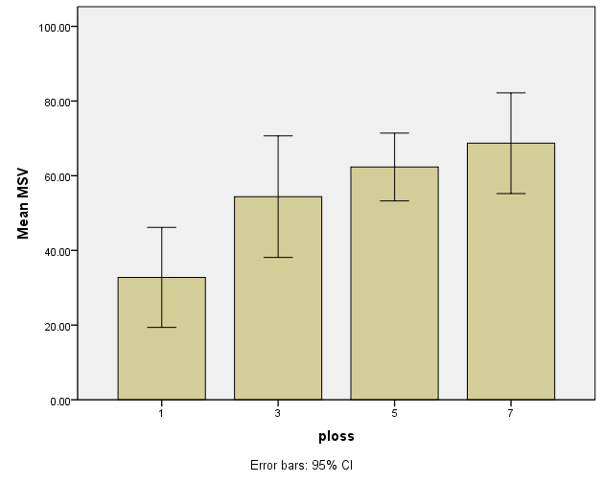

As it is visible from the graphs, Mean Annoyance and Stregth scores are not significantly different among Setting 3 and 5 and among setting 5 and 7, whereas they are among setting 3 and 7. As a result, we decided to drop setting 5.

Eventually, we narrowed down the parameters to:

Packet Loss (PL) 🡪 {0, 1, 3, 7}

Blockiness (BO) 🡪 {0, 0.4, 0.6}

Blurriness (BU) 🡪 {0, 0.4, 0.6}

where the video with PL = BO = BU = 0 is the pristine video.

The full factorial design would then be:

|  |  |  |  |  |
| --- | --- | --- | --- | --- |
| **Combination** | **Packet Loss ratio** | **Blockiness** | **Blurriness** | **MAV/MSV** |
| 1 | 0 | 0 | 0 | existing |
| 2 | 0 | 0 | 0,4 | existing |
| 3 | 0 | 0 | 0,6 | existing |
| 4 | 0 | 0,4 | 0 | existing |
| 5 | 0 | 0,4 | 0,4 |  |
| 6 | 0 | 0,4 | 0,6 | existing |
| 7 | 0 | 0,6 | 0 | existing |
| 8 | 0 | 0,6 | 0,4 | existing |
| 9 | 0 | 0,6 | 0,6 |  |
| 10 | 1 | 0 | 0 | existing |
| 11 | 1 | 0 | 0,4 |  |
| 12 | 1 | 0 | 0,6 |  |
| 13 | 1 | 0,4 | 0 |  |
| 14 | 1 | 0,4 | 0,4 |  |
| 15 | 1 | 0,4 | 0,6 |  |
| 16 | 1 | 0,6 | 0 |  |
| 17 | 1 | 0,6 | 0,4 |  |
| 18 | 1 | 0,6 | 0,6 |  |
| 19 | 3 | 0 | 0 | existing |
| 20 | 3 | 0 | 0,4 |  |
| 21 | 3 | 0 | 0,6 |  |
| 22 | 3 | 0,4 | 0 |  |
| 23 | 3 | 0,4 | 0,4 |  |
| 24 | 3 | 0,4 | 0,6 |  |
| 25 | 3 | 0,6 | 0 |  |
| 26 | 3 | 0,6 | 0,4 |  |
| 27 | 3 | 0,6 | 0,6 |  |
| 28 | 7 | 0 | 0 | existing |
| 29 | 7 | 0 | 0,4 |  |
| 30 | 7 | 0 | 0,6 |  |
| 31 | 7 | 0,4 | 0 |  |
| 32 | 7 | 0,4 | 0,4 |  |
| 33 | 7 | 0,4 | 0,6 |  |
| 34 | 7 | 0,6 | 0 |  |
| 35 | 7 | 0,6 | 0,4 |  |
| 36 | 7 | 0,6 | 0,6 |  |

If we wanted to cover all non-existing combination, that would result into **26(combinations)x7(videos) + 7 (pristine videos) = 189 test sequences**. This is a too large amount to be judged in a single experiment. Thus, choices have to be made on which videos to select (about 10 versions have to go).

An idea could be avoiding the combinations where blockiness and blurriness are in the same amount. that would take out already 6 combinations. Perhaps other combinations can be discarded once all the videos have been prepared.

[1] Farias, M., Heyinderickx, I., Machiavello, B. and Redi J., “Visual Artifacts Understanding and Modeling (VARIUM)”, International Workshop on Video Processing and Quality Metrics (VPQM 2013), 2013